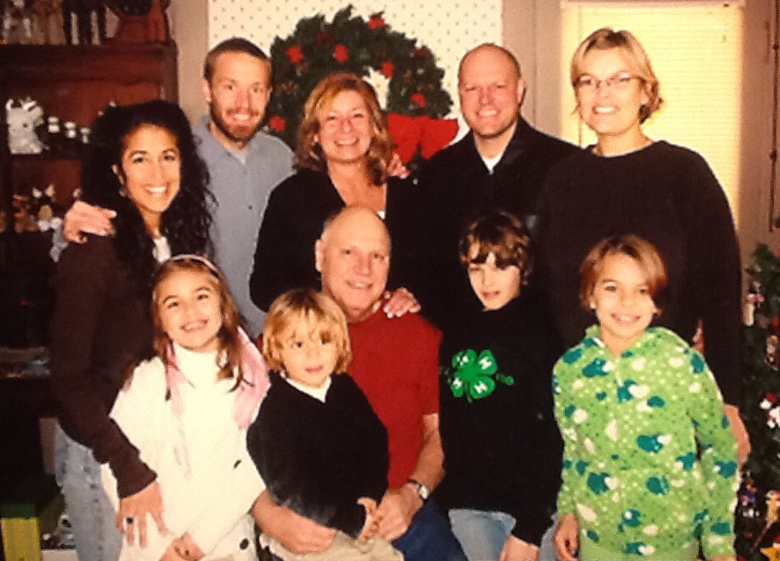

(l-r) Back Row: Gigi, Aaron John, Tamey, Tyler, Laura

Front Row: Zoe, Russell, John, Eryn, Leah – about 2007

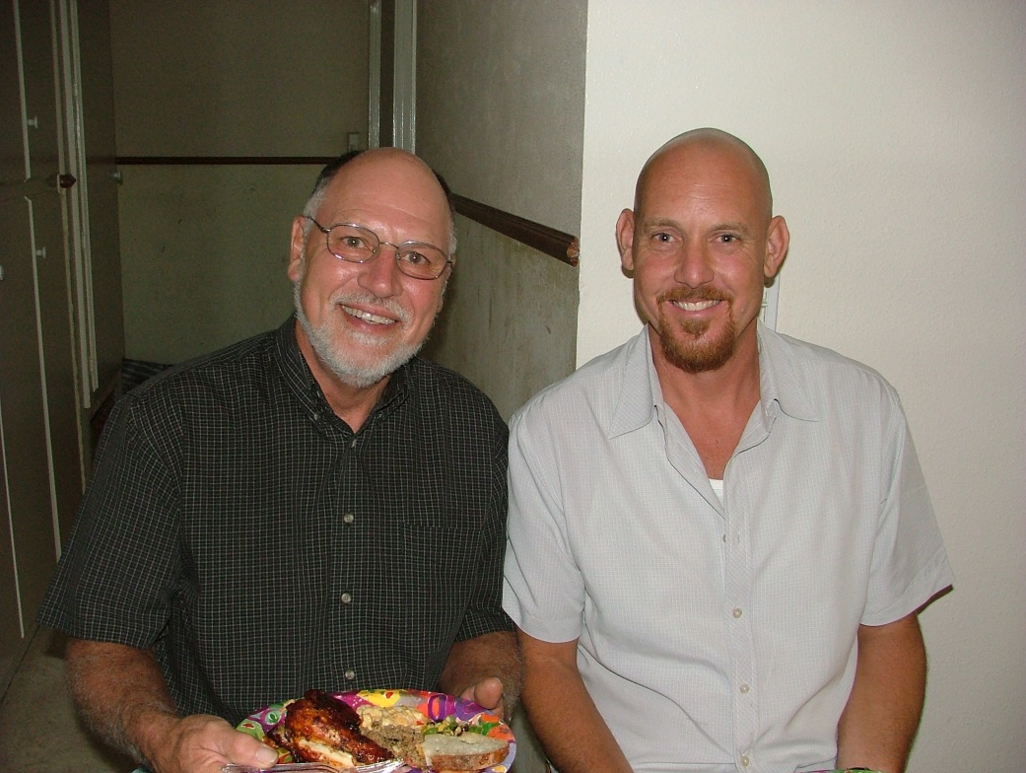

John Earl Wolfe and Brian Crenshaw Moore – 2007